Step 1: Product Vision

Problem
Roblox developers often showcase their work through scattered links:
- Roblox profile
- Discord
- Twitter/X
- YouTube
- Google Drive
- DevForum
- Random screenshots
There isn't a simple, professional portfolio focused specifically on Roblox development.

Solution
Create a web platform where Roblox developers can:
- Create a professional profile
- Showcase their projects
- Upload images and videos
- Describe their work
- Allow interested people to request a private chat

Target Users
Primary:
- Roblox programmers
- Builders
- UI designers
- VFX artists
- Scripters
- Animators
- Modelers
Secondary:
- Studio owners
- Recruiters
- Clients
- Team leads

Step 2: Define the MVP Goal
The MVP should accomplish one thing exceptionally well.
"A Roblox developer can create a professional portfolio that showcases their work and allows potential clients to initiate contact."
Notice what is not included:
❌ Marketplace
❌ Payments
❌ Reviews
❌ Teams
❌ Analytics
❌ AI
❌ Followers
❌ Messaging system
❌ Notifications
Those are future versions.

Step 3: Functional Requirements
Now we write requirements almost like a Software Requirements Specification (SRS).

Authentication
Users should be able to:
- Register an account
- Log in
- Log out
- Reset password
- Verify email

User Profile
Each user has one profile.
Fields:
Basic Information
- Display Name
- Username
- Profile Picture
- Banner
- Tagline
- Bio
Professional Information
- Primary Role
Examples:
- Builder
- Scripter
- UI Designer
- Animator
- Modeler
- VFX Artist
Optional secondary roles.
Experience Level
- Beginner
- Intermediate
- Advanced
- Professional
Location (optional)
Languages
Social Links
- Roblox
- Discord Username
- GitHub
- YouTube
- X
- Website
Availability
- Open for work
- Busy
- Not available

Portfolio Projects
A user can create multiple projects.
Each project contains:
Title
Short Description
Detailed Description
Thumbnail
Media Gallery
Supports:
- Images
- Videos
Tags
Example:
Adventure
Simulator
FPS
RPG
Tycoon
Showcase
Completion Status
- Completed
- In Progress
Date Created
Visibility
- Public
- Private

Portfolio Display
Visitors should be able to:
View Profile
↓
See Bio
↓
See Skills
↓
Browse Projects
↓
Open Project
↓
View Images
↓
Play Videos
↓
Request Chat

Chat Request System
This is intentionally not a messaging system.
Instead:
Visitor presses
Request Chat
They fill:
- Name
- Short message
Example:
Hi, I'm interested in hiring you for a simulator project.
Submit.
Developer receives request.
Developer can:
Accept
Decline
Pending
If accepted:
Show developer's Discord username or preferred contact method.
This avoids building an entire real-time chat infrastructure in V1.

Dashboard
Logged-in users have a dashboard.
Dashboard includes:
Profile
Projects
Chat Requests
Settings

Profile Editing
User can edit:
Bio
Images
Banner
Skills
Roles
Socials
Availability

Project Management
Users can:
Create project
Edit project
Delete project
Upload media
Reorder media
Publish project
Hide project

Media Upload
Supported:
Images
Videos
Limits:
Maximum image size
Maximum video size
Allowed formats
Storage solution

Search
Visitors can search:
Developer name
Username
Role
Tags

Browse Developers
Visitors should be able to browse:
Newest
Recently updated
Builders
Programmers
Artists

Public Portfolio Page
Example
Cover Banner

Profile Picture

Display Name

Tagline

Bio

Skills

Projects

Request Chat Button

Step 4: Non-functional Requirements
Performance
- Pages load under 2 seconds
- Optimized images
- Lazy loading
Security
- Password hashing
- JWT authentication
- Rate limiting
- Secure uploads
Scalability
Architecture should support future:
- Messaging
- Marketplace
- Teams
- Reviews
Responsive
Desktop
Tablet
Mobile
SEO
Public profiles indexable.
Accessibility
Keyboard navigation
Alt text
Semantic HTML

Step 5: User Stories
These are how Agile teams typically express requirements.

Authentication
As a developer,
I want to create an account,
so that I can build my portfolio.

As a developer,
I want to log in,
so I can manage my projects.

Portfolio
As a developer,
I want to upload screenshots,
so visitors can see my work.

As a developer,
I want to upload gameplay videos,
so clients understand my projects.

As a visitor,
I want to browse portfolios,
so I can discover talented Roblox developers.

As a visitor,
I want to view project details,
so I can evaluate someone's work.

As a visitor,
I want to request a chat,
so I can contact a developer.

As a developer,
I want to review chat requests,
so I can decide whether to respond.

Step 6: What We Explicitly Exclude from V1
This is just as important as defining what is included.
Authentication & Accounts
- OAuth (Google, Discord, Roblox login)
- Two-factor authentication
- Multiple account types
Social Features
- Likes
- Comments
- Followers/following
- Activity feed
- Notifications
Messaging
- Real-time chat
- Group chats
- File sharing
- Read receipts
Portfolio Enhancements
- Analytics
- Project collaboration
- Team profiles
- Custom themes
- Drag-and-drop page builder
Discovery
- Recommendation engine
- Featured creators
- Trending portfolios
- Advanced filtering
Monetization
- Premium subscriptions
- Advertisements
- Commission payments
- Escrow
Integrations
- Automatic Roblox API synchronization
- GitHub repository import
- Discord bot integration

Suggested V1 Success Metrics
Before building V2, decide how you'll know V1 is successful. For example:
- Users can sign up and publish a portfolio in under 10 minutes.
- Every public profile has a unique, shareable URL.
- Visitors can browse portfolios without logging in.
- Developers can showcase multiple projects with images and videos.
- Visitors can submit contact requests successfully.
- Developers receive and manage those requests through their dashboard.

I would make one architectural change to your current plan: replace the "1-on-1 chat request" with a "Contact Request" feature in V1. Instead of building a messaging system, let visitors send a request with a short message. When the developer accepts it, they can reveal their preferred contact method (such as Discord). This provides the core value—connecting developers and potential clients—while avoiding the complexity of WebSockets, real-time messaging, notifications, typing indicators, message history, moderation, and online presence. It also leaves room to introduce a full messaging system as a compelling V2 feature without having to redesign your architecture.

Design Reference:
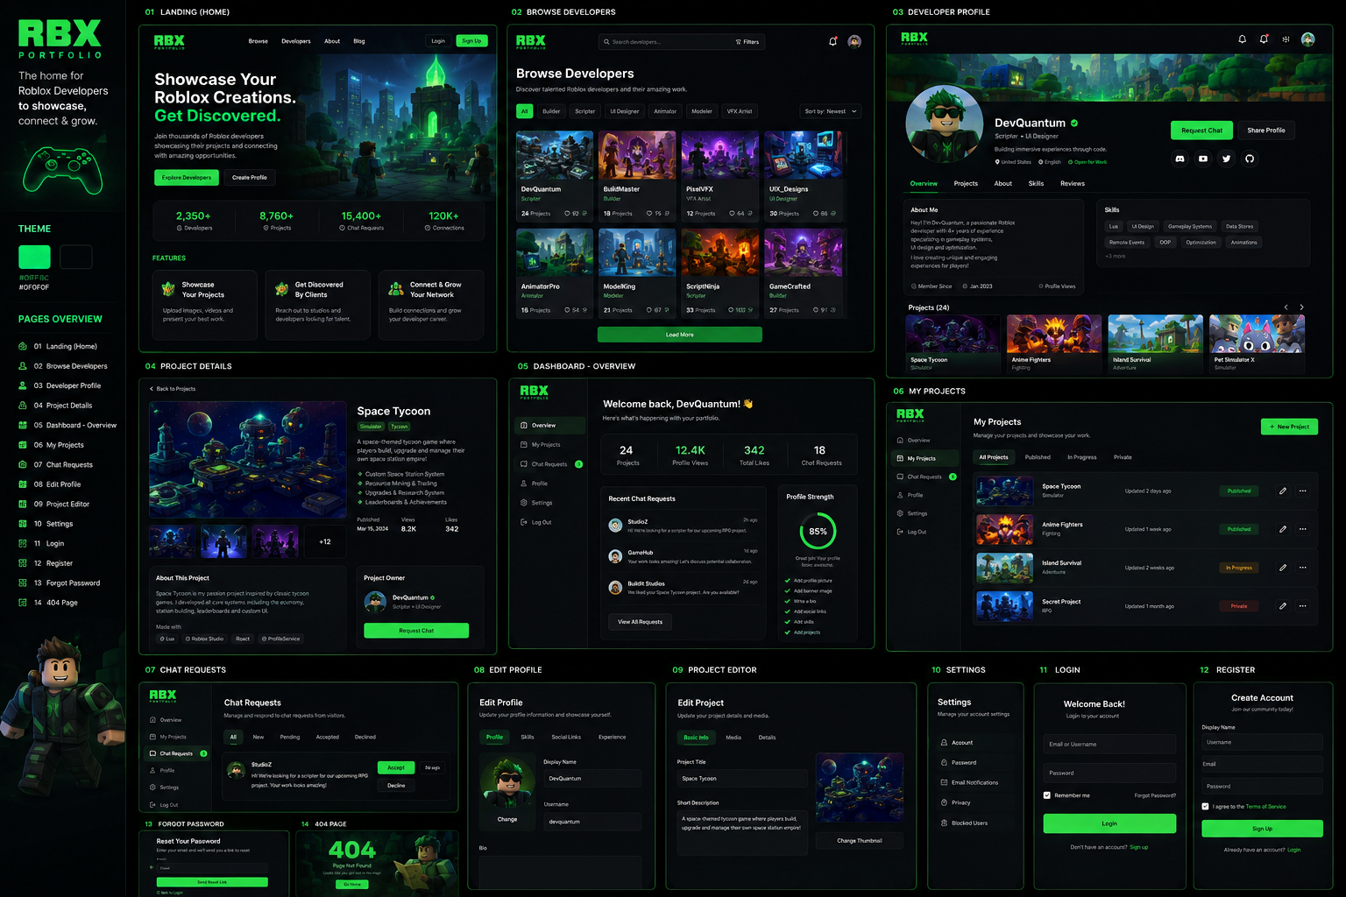
Since you're building this as a startup with plans to iterate over multiple versions, I'd optimize for developer experience, scalability, and performance, in that order. You don't need the most complex architecture—you need one that lets you ship quickly without painting yourself into a corner.
Here's the stack I'd recommend.

Frontend

Next.js (App Router) + React + TypeScript
Why?
- Excellent SEO (important for public developer portfolios)
- Server Components reduce unnecessary client-side JavaScript
- Fast page loads
- Great image optimization
- Built-in routing and metadata
- Easy deployment
- Large ecosystem
Use:
- App Router
- Server Components by default
- Client Components only when necessary

Styling

Tailwind CSS
Why:
- Fast development
- Small production CSS
- Easy responsive layouts
- Great design consistency
Add:
- shadcn/ui
- Radix UI
- Framer Motion
This combination gives you polished components while keeping full control over styling.

Icons
- Lucide React
Simple, lightweight, tree-shakable.

Animations
Framer Motion
Use it sparingly:
- Page transitions
- Hover effects
- Cards
- Buttons
- Modals
Avoid over-animating. Performance is more important.

Backend

NestJS
Since you've already started learning it, it's a strong fit.
Benefits:
- Modular architecture
- Dependency Injection
- TypeScript
- Authentication support
- Validation
- Easy scaling
- Great maintainability
Structure:
Auth Module

Users Module

Projects Module

Media Module

Chat Requests Module

Admin Module

Search Module

Database

PostgreSQL
Reasons:
- Extremely reliable
- Excellent relational support
- Great search capabilities
- JSON support
- Easy migrations
- Works well with Prisma
Your app is relational by nature:
User

↓

Projects

↓

Images

↓

Videos

↓

Chat Requests
Postgres handles this exceptionally well.

ORM

Prisma
Benefits:
- Excellent TypeScript support
- Auto-generated types
- Easy migrations
- Intuitive queries
- Strong developer experience

Authentication
I'd recommend:

Better Auth
Why over alternatives?
- Modern
- TypeScript-first
- Supports sessions
- Supports OAuth later
- Database-backed sessions
- Great with Next.js
Start with:
- Email/password
- Email verification
- Password reset
Later add:
- Discord login
- Google login
- Roblox OAuth (if desired)

File Storage
Don't store media in PostgreSQL.
Instead:
Images/videos
↓
Cloud Storage
Options:
- Cloudflare R2 ⭐ (recommended)
- AWS S3
- Backblaze B2
Cloudflare R2 is attractive because:
- S3-compatible
- No egress fees
- Affordable
- Global CDN integration

Image Optimization
Use:
Next.js Image
Store multiple sizes:
Thumbnail

Medium

Full Resolution
Never serve original 10 MB images directly.

Video Storage
Store videos in Cloudflare R2.
Future:
Use Cloudflare Stream if user-uploaded video volume grows significantly.

Search
For V1:
PostgreSQL search
Search by:
- Username
- Project
- Tags
- Skills
Later:
Algolia
or
Meilisearch

Validation
Zod
Use it for:
Frontend
↓
Backend
Shared types
Excellent integration with React Hook Form.

Forms
React Hook Form
Combined with:
Zod
Produces excellent performance and minimal re-renders.

API
I'd keep it simple:
REST API
Examples:
GET /users

GET /projects

POST /projects

PATCH /profile

POST /chat-request
GraphQL isn't necessary yet.

State Management
You'll likely need very little global state.
Use:
- TanStack Query (server state)
- Zustand (small client state)
- React Context (theme, auth)
Avoid Redux for now.

Caching
For V1:
- Next.js caching
- Browser caching
- CDN caching
Later:
Redis
For:
- Rate limiting
- Session storage (if needed)
- Popular profile caching

Email
Resend
Use it for:
- Verification emails
- Password reset
- Contact notifications
Simple, reliable, and developer-friendly.

Deployment

Frontend
Vercel
Perfect fit for Next.js.

Backend
Railway
or
Coolify VPS
or
Hetzner VPS
I wouldn't deploy NestJS on Vercel.

Database Hosting
Neon PostgreSQL
Excellent for startups.
Benefits:
- Branching
- Autoscaling
- Backups
- Serverless-friendly

CDN
Cloudflare
For:
- Images
- Static assets
- DNS
- Security
- DDoS protection

Monitoring
Sentry
Tracks:
- Exceptions
- Stack traces
- Frontend errors
- Backend errors

Analytics
PostHog
Track:
- Portfolio views
- Search usage
- Chat request submissions
- User onboarding
More actionable than simple page-view analytics.

Testing
Initially:
- Vitest (unit tests)
- Playwright (end-to-end tests)
You don't need 100% coverage in V1, but having tests for core flows (authentication, project creation, contact requests) will pay off as the product grows.

CI/CD
GitHub
↓
GitHub Actions
↓
Run:
- ESLint
- Type checking
- Unit tests
- Build verification
↓
Deploy automatically

Architecture
Users
│
▼
Next.js Frontend
│
Server Components + Client Components
│
REST API
│
NestJS Backend
│
┌───────────────┼────────────────┐
▼ ▼ ▼
PostgreSQL Cloudflare R2 Resend
(Prisma) (Media Storage) (Email)
│
▼
Cloudflare CDN

Recommended Folder Structure
apps/
├── web/ # Next.js frontend
└── api/ # NestJS backend

packages/
├── ui/ # Shared UI components
├── types/ # Shared TypeScript types
├── config/ # Shared configuration
└── eslint-config/ # Shared lint rules
Using a monorepo (for example, with Turborepo or pnpm workspaces) makes it easier to share types and utilities between the frontend and backend as the project grows.

Final Stack Summary
Layer | Recommendation
Frontend | Next.js (App Router) + TypeScript
Styling | Tailwind CSS + shadcn/ui + Radix UI
Animations | Framer Motion
Backend | NestJS
Database | PostgreSQL (Neon)
ORM | Prisma
Authentication | Better Auth
Forms | React Hook Form + Zod
State Management | TanStack Query + Zustand
File Storage | Cloudflare R2
Image Optimization | Next.js Image
Email | Resend
Search | PostgreSQL Full-Text Search (V1)
Analytics | PostHog
Monitoring | Sentry
Frontend Hosting | Vercel
Backend Hosting | Railway (or a VPS with Coolify as you scale)
CDN/DNS | Cloudflare
Version Control & CI | GitHub + GitHub Actions

